SISTER NIVEDITA MONTESSORY SCHOOL
NURSERY
HINDI
PRACTICE 3 PAGES
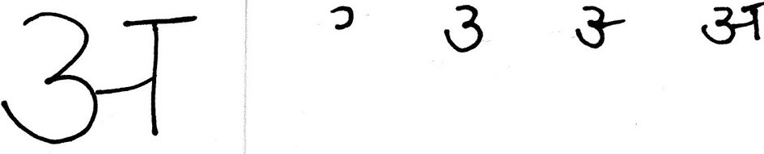
WRITING PATTERN EX BOOK 1- COMPLETE PG 13 & 14.
WRITING PATTERN EX BOOK 2 - COMPLETE PG 4.
PRACTICE NUMBER 1(ONE) - GO- OVER.

PRACTICE NUMBER 2 (TWO)- GO -OVER
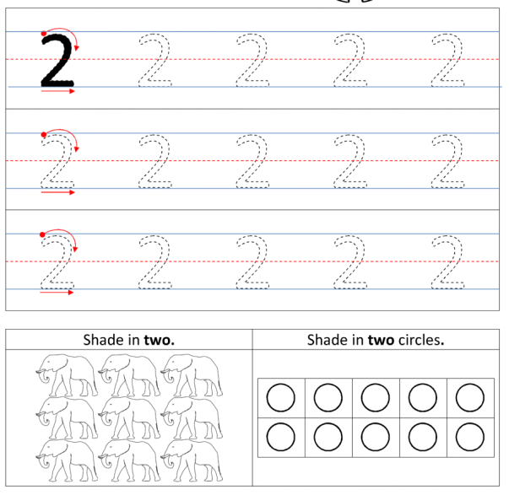
PUT YOUR FINGER & READ “A” TO “T” FROM FILE.
PUT YOUR FINGER & READ  
PUT YOUR FINGER & READ “1” TO “30” FROM FILE.

